Devin Carree

August 17, 2019

Independent Project

**Stem-Cell Applications in Neuro-regenerative Therapies**

**Introduction**

Many people today suffer from a wide array of diseases that affect the nervous system by degenerating nervous tissue, neurons and glia. Cells of the central and peripheral nervous system (CNS/PNS), unlike skin cell and bone cells, are one of the few types of cells that are not readily available to divide. Therefore, nervous tissues are destroyed, due to injury or disease, they are not able to be replaced which causes a significant loss of function in the life of a human being. These include diseases such as Parkinson’s disease, which selectively degenerates dopaminergic neurons in the substaintia nigra pars compacta, Huntington’s disease, an autosomal dominant neurodegenerative disorder, Amyotrophic Lateral Sclerosis (ALS) or Lou Gehric disease, which non-selectively degrades motor neurons in the cerebral cortex, brain stem and spinal cord, causing muscle wasting and weakness and eventually death, Alzehmier’s disease, which is causes loss of neurons and synapses specifically in the basal forebrain, amygdala, hippocampus and cortical area (1). In diseases such as ALS and Huntington’s disease, because of the wide range and diversity of its effects, it is unrealistic to believe that stem cells can replace all affected cells and restore motor function completely but they can help reduce symptoms and improve quality of life(1,2). But for diseases such as Parkinson’s disease, where only the dopaminaergic neurons of substaintia nigra pars compacted are affected, stem cells have been proven to have the ability to alleviate the symptoms of Parkinson’s disease allowing people to live a life similar to having no disease at all (3,4). Stem cells are cells that can replicate themselves indefinitely as well as differentiate into many different types of cells (1). There are different types of stems cells. They categorized as unipotent, multipotent, pluripotent and totipotent, based on their ability to differentiate to other cells (1,5). Unipotent and multipotent types pf stems cells would be the least useful as they would only be able to differentiate into small amount different types of cells. The only types of multipotent stem cells that would be useful for regeneration of nervous tissue would be neural stem cells and mesenchymal stem cells which have been proven to be able to turn into neurons (3). The most useful type of stem cells would be pluripotent or totipotent, as they have the ability to turn into every cell in the adult human body, in the case of pluripotent cells; in the case of totipotent cells, they are able to differentiate into every cell in the human body including extra-zygotic cells such as the umbilical cord or the placenta (1,5). Embryonic stem cells derived from the inner cell mass of a developing zygote or fetal stem cells has been indicated as the best type of stem cells, in regards to generating new functional neurons, as they are pluripotent with the ability to differentiate into every cell in the body (except the placenta), including nervous tissue(1). This is shown in figure 1. Although embryonic stem cells have the best efficiency, there are some ethical questions that are raised based on how the cells are retrieved. To circumvent these questions and ethics new research has discovered the ability to create pluripotent stem cells using adult somatic cells such as fibroblast. These newly invented types of cells are adult somatic cells that are reprogrammed and to act very similarly to embryonic stem cells, by exhibiting similar morphology, growth properties and cell marker genes. These are called induced pluripotent stem cells (iPSCs).

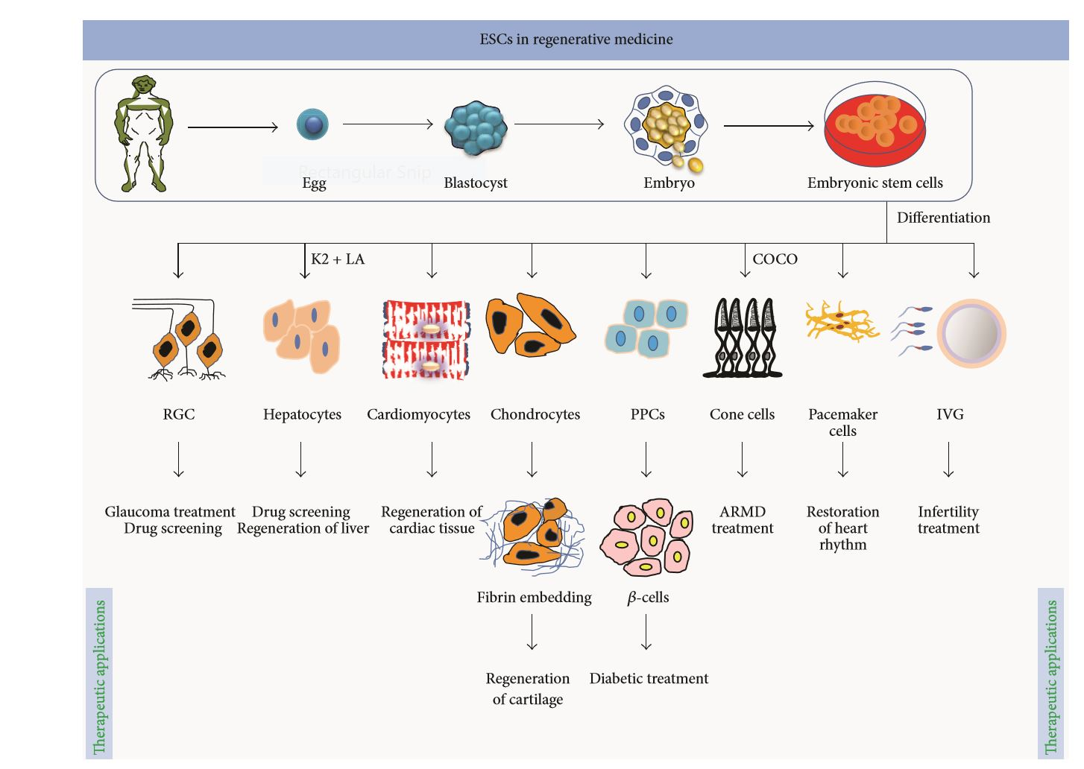(7)

Figure 1. Shows the pathway of embryonic stem cells beginning from an adult human, to embryonic stem cells, to differentiated adult somatic cells. Embryonic stem cells can turn into more than 200 types of cells in the adult human body. This figure shows a small amount of the different type of adult somatic cells that embryonic stem cells can become. (7)

**Gap in Knowledge**

Most research would regard embryonic stem cells as being better and more reliable than induced pluripotent stem cells but because of the question of ethics as well as iPSCs’ ability to avoid transplantation rejection, with the improvement of its ability and efficiency to differentiate and survive in a patient, iPSCs will be the tool used for regenerative medicines and therapies in the future. Adult human somatic cells terminally differentiated can be reprogramed into an embryonic-like state by restoration of endogenous pluripotency factors such as OCT4, SOX2, and Nanog (6,7). This can be done by either retro-viral or lenti-viral infection, or introduction of reprogramming proteins directly into human fibroblast using cell penetrating peptides (8). Currently there are many issues that scientist and researchers face in order to increase the efficiency of stem cell therapies. One challenge is the ability to create cell types that would produce therapeutic actions (1). Although scientist have proven the ability to turn human somatic cells into stem cells that can function properly as neurons, the ability to differentiate neurons into even more differentiated types or subsets of neurons, without cellular bias, has yet to be shown (9). This is shown in figure 2. Another obstacle that stem-cell therapies face is the formation of tumors after the transplantation of the iPSC. Oncogenes are added to stem cell lines to help them maintain their ability to replicate indefinitely (1,10). This replication is very important ex-vivo and even essential for the culture cells to be classified as stem cells but in-vivo can cause serious complications and even cancer. The last obstacle for researchers is understanding the mechanism by which the stem cells achieve their function (1). Not understanding the mechanism would not necessarily translate to an inadequate treatment or therapy; and if clinical trials were successful in treating symptoms of suffering patients the treatment should be taken advantage of but after understanding the underlying mechanisms we could understand the underlying therapeutic action and try to recapitulate them in other models, other diseases or future research.

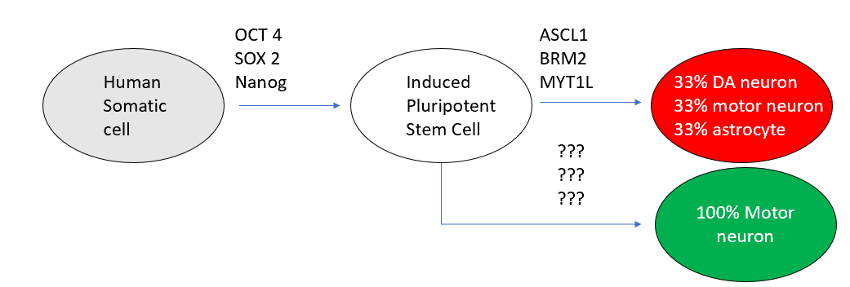

**Current Challenges/ Future Perspectives**

Stem cells research holds a great amount of promise for knowledge for future researchers. Because this field is still relatively new there is a lot of information that we do not know about stem cells. For example, researchers don’t know the underlying mechanisms of how stem cell therapies alleviate symptoms that are associated with the disease (1), so after discovery and study of what is being done physiologically to alleviate symptoms these studies can be translated to other studies expanding research efforts significantly. Outcomes of this research can include improvements in disease modeling, drug screening and disease treatment (2). Disease modeling is important because it is the way that we study disease. Because we cannot remove nervous tissue from a living human being at an effective quantity, we cannot use live human cells to study the progression of the disease. Researchers generated iPSCs and eventually motor neurons using adult fibroblast cells from a patient diagnosed with spinal muscular atrophy. These cells survived and proliferated robustly but maintained disease genotype and showed similar motor neuron deficits to what the subject experienced (11). This is significant because the cell shows the genotype and phenotype of the disease that is present in living human beings. Using cell specific markers, we can determine anomalies between diseased cell states and regular healthy cells. A challenge faced is determining the exact environment that will produce a cell that is the correct very specific cell. (2,11). If we want to recapitulate Parkinson’s disease in a human model using these types of cells, we would need to be able to differentiate the neural progenitor cell into the specific DA cell of the substantia nigra pars compacta. Another challenge is to achieve the late onset phenotype, in-vitro, as reported in ALS, Parkinson’s and dementia. (1,12) As early onset cases of these disease account for less than 10% (1) it is very important to achieve similar etiologies in-vitro as in-vivo. Another important aspect that stem cell research could bring to the forefront in future knowledge is improvements in drug screenings. This is important because the cost of drug development is too much and needs to be improved. Approximately 90% of drugs tested in clinical trials are never sold in market due to the limits of disease modeling and failed drug safety tests (1). Using iPSC both the toxicity of the drugs and its effectiveness could be tested at the same time improving the efficacy of testing. Determining innovative ways to create stem-cells would also open doors for learning different subjects that are related to stem-cells. For example, Jönsson et al. discovered that inactivation of DMTN1 in human embryonic stem cells results in viable, proliferating cells along with simultaneous global demethylation (13). This leaves open questions in the field of epigenetics instead of genetics. What role does methylation play in differentiation? What role does it play in development of disease? These open-ended questions can lead to innovative studies that can improve the science being learned today. I believe that stem cells will be the gate-way subject to curing many if not all genetic impairments.

**Works Cited**

1. Kim S, Lee H, Kim Y, Neural stem cell-based treatment for neurodegenerative diseases Neuropathology (2013); 33, 491–504
2. Lindvall O, Kokaia Z. Stem cells for the treatment of neurological disorders. Nature 2008; 441: 1094–1096
3. Jung YW, Hysolli E. Kim KY, et al. Human induced pluripotent stem cells and neurodegenerative disease: prospects for novel therapies. Curr Opin Neurol . (2012);25(2): 125–130
4. Wernig M, et al. Neurons derived from reprogrammed fibroblasts functionally integrate into the fetal brain and improve symptoms of rats with Parkinson's disease. Proceedings of the National Academy of Sciences of the United States of America. 2008; 105(15):5856–5861. [PubMed: 18391196]
5. Fortier L.A., “Stem cells: classifications, controversies, and clinical applications, “Veterinary Surgery, vol. 34, no. 5, pp. 415– 423,2005.
6. Takahashi K., Yamanaka S., “Induction of pluripotent stem cells from mouse embryonic and adult fibroblast cultures by defined factors,” Cell,vol.126,no.4,pp.663– 676,2006.
7. Mahla R, Stem Cells Applications in Regenerative Medicine and Disease Therapeutics. International Journal of Cell Biology (2016) Volume 2016, Article ID 6940283
8. Kim D, et al. Generation of human induced pluripotent stem cells by direct delivery of reprogramming proteins. Cell Stem Cell. 2009; 4(6):472–476.
9. Perrier AL, et al. Derivation of midbrain dopamine neurons from human embryonic stem cells. Proceedings of the National Academy of Sciences of the United States of America. 2004; 101(34): 12543–12548.
10. Oshima, Kazuo et al. “LIF promotes neurogenesis and maintains neural precursors in cell populations derived from spiral ganglion stem cells.” *BMC developmental biology*  vol. 7 112. 12 Oct. 2007,
11. Ebert A, Yu J, Rose F, et al. Induced pluripotent stem cells from a spinal muscular atrophy patient. Nature. (2009) January 15; 457(7227): 277–280.
12. Boulting G, Kiskinis E, Croft, G. A functionally characterized test set of human induced pluripotent stem cells. Nat Biotechnol . (2011) ; 29(3): 279–286
13. Jönsson M, Brattå P, Gustafsson C, Activation of neuronal genes via LINE-1 elements upon global DNA demethylation in human neural progenitors Nature Communications (2019)10:3182